**BoJack Horseman**

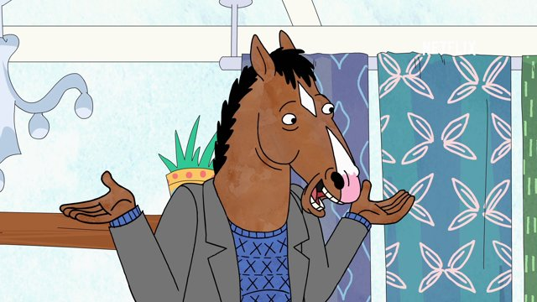

**-20°C Freezer**

Wear gloves when handling freezer items

**Princess Carolyn**

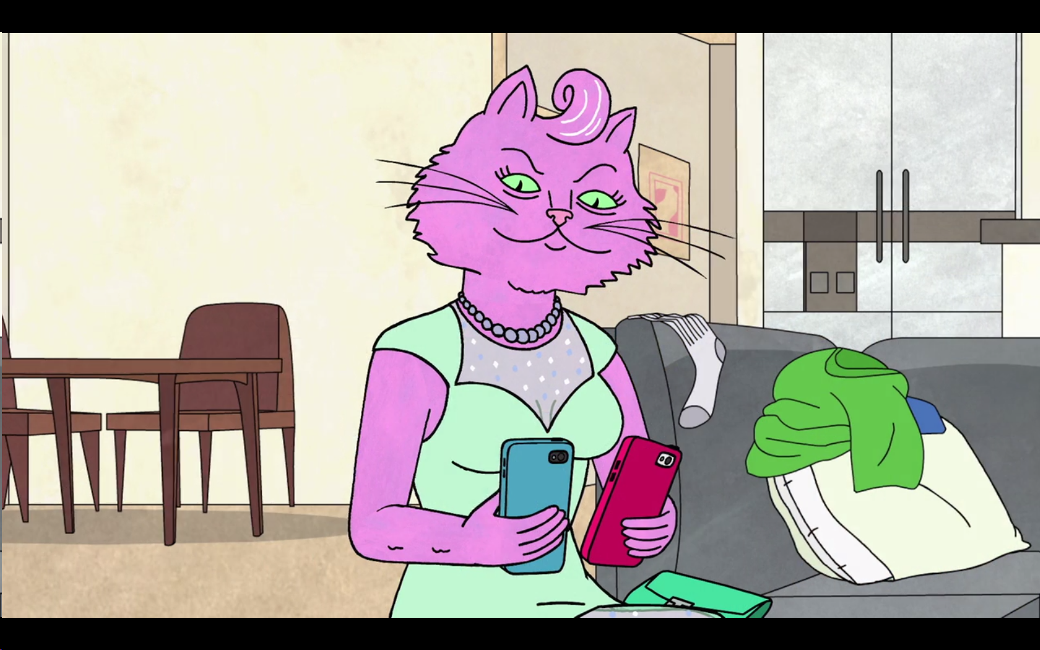

**4°C Refrigerator**

Wear gloves when handling fridge items